How To – Secure Toolbooks

Making the following changes will prevent unauthenticated access to the toolbooks and their content.
Essentially this is done by configuring IIS to use the ASP.Net ISAPI executable to serve up these files as opposed
to just serving them directly. This ensures that when a client requests a file, they will be redirected to the login page if they
haven’t already logged in.

These are the steps involved.

Right click on the website and select properties
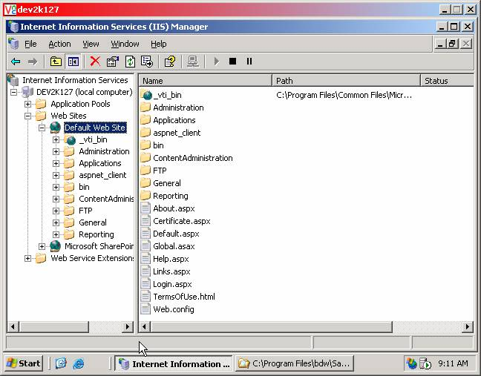

The following screen will be shown
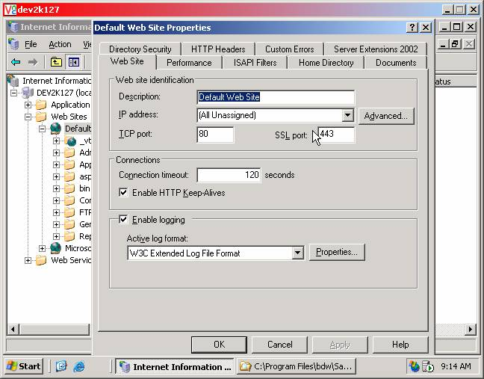

Select the "Home Directory" tab then the "Configuration" button
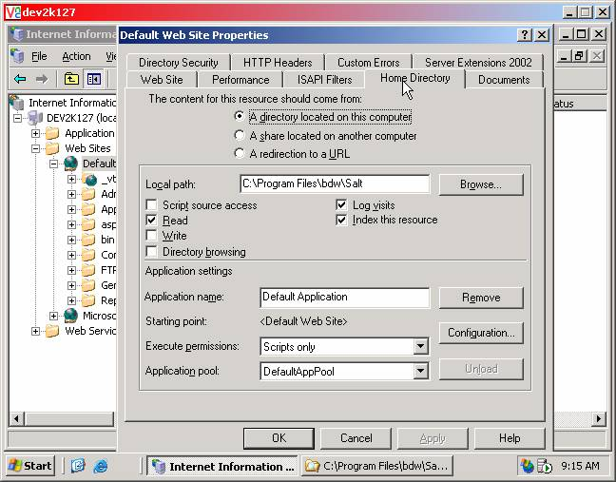

The following screen will be shown
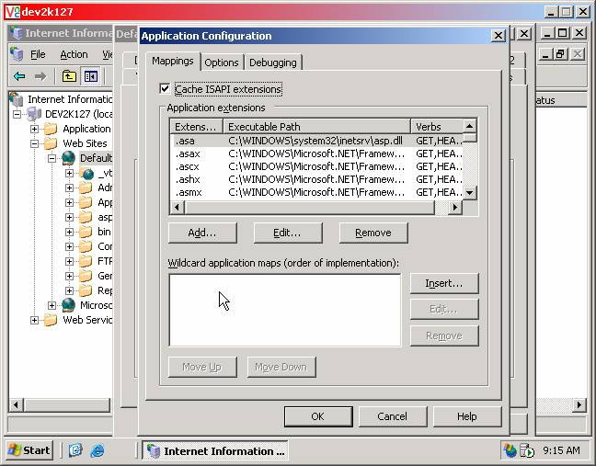

Select "Add"
Executable: C:\WINDOWS\Microsoft.NET\Framework\v1.1.4322\aspnet_isapi.dll
Extension: html
Press "OK"
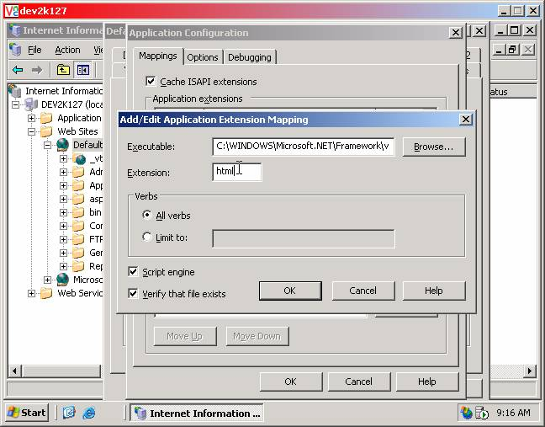

Select "Add"
Executable: C:\WINDOWS\Microsoft.NET\Framework\v1.1.4322\aspnet_isapi.dll
Extension: xml
Press "OK"
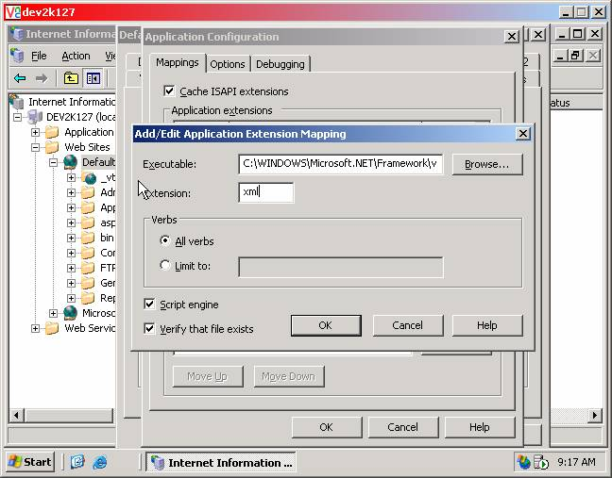

Press 'OK'
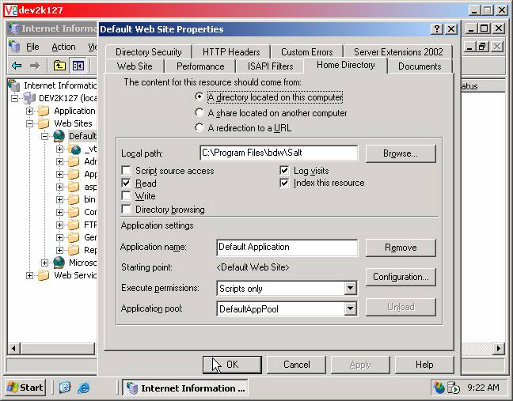

Restart IIS for these new settings to take effect.

These changes can be tested by attempting to browse directly to a toolbook
ie: http://host.domain.com/General/Toolbook/Content/1/1/lesson/ie4/index.html

